Computer Science: An Overview
Homework Set 1
September 20, 2025
By Deng Yufan
1. (2’) In the following flip-flop, what is the output when
- both inputs remain 0? |  | 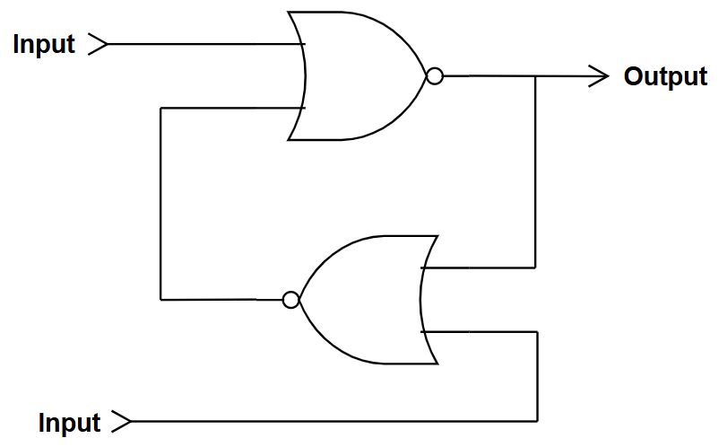
- both inputs remain 1?
- the upper input remains 0 and the lower remains 1?
- the upper input remains 1 and the lower remains 0?
Choose one of the following options for each case and fill it in the form (in uppercase).
A. 1 B. 0 C. Switch between 0 and 1 D. Keep the previous output
(1) | D | (2) | B, but if the two input changes to 0 at the same time, the output will be unpredictable.
(3) | A | (4) | B

2. (2’) Encode the value -6 into its equivalent 8-bit binary representation (Fill an 8-bit 0/1 string in the form, e.g., 00000001).
- True Form | - One’s Complement | - Two’s Complement | - Excess-128

a. | 10000110 | b. | 11111001
c. | 11111010 | d. | 01111010

3. (2’) Perform the following additions. The bit patterns represent values in 8-bit two’s complement representation. The answers should also be given in 8-bit two’s complement representation. Hint: overflows may occur in some cases. (Fill an 8-bit 0/1 string in the form, e.g., 00000001)
- 00101010 + 00001111 | - 00011010 + 01010101
- 10001001 + 00110011 | - 00010100 + 11110110

a. | 00111001 | b. | 01101111
c. | 10111100 | d. | 00001010

4. (2’) Encode the following values using the 8-bit floating-point format discussed in class (Fill an 8-bit 0/1 string in the form, e.g., 00000001).
- $2\frac{5}{8}$ | - $-1\frac{3}{4}$ | - $\frac{13}{16}$ | - -2

a. | 01101010 | b. | 11011110
c. | 01001101 | d. | 11101000

5. (2’) In each of the following problems, interpret the bit patterns using the 8-bit floating-point format, add the values represented and encode the answer in the same floating-point format. Hint: truncation errors may occur in some cases. (Fill an 8-bit 0/1 string in the form, e.g., 00000001)
a. 01111000 + 01101100 | b. 11011100 + 01101000
c. 00101000 + 01011001 | d. 01011000 + 11011100

a. | 01111110 | b. | 01001000
c. | 01011010 | d. | 11001000

